**MINISTRY OF EDUCATION AND TRAINING**

**FPT UNIVERSITY**

Capstone Project Document

**Computer Product Suggestion**

|  |  |
| --- | --- |
| **Group 13** | |
| **Group member** | Pham Hong Sang – Team Leader – SE60601  Huynh Thanh Viet – Team Member - SE60666  Tran Tan Len – Team Member - SE60623  Ha Chi Danh – Team Member – 60431 (Dropped out) |
| **Supervisor** | Mr. Kieu Trong Khanh |
| **Ext. Supervisor** | N/A |
| **Capstone Project code** | CPS |

-Ho Chi Minh City, 05/2014-

*This page is intentionally left blank*

***ACKNOWLEDGEMENTS***

We wish to thank various people for their contribution to this project: Our teachers for their advice and participation in the final review, our friends for their valuable technical support.

Special thanks should be given to Mr. Kieu Trong Khanh, our research supervisor for his professional guidance and the useful, constructive recommendations throughout the course of this project.

# Table of Contents

Table of Contents 2

A. Software Project Management Plan 2

1. Problem Definition 2

1.1 Name of this Capstone Project 2

1.2 Problem Abstract 2

1.3 Current Comparison websites in Vietnam 2

1.4 The Proposed System 2

2. Solution đang phân vân 2 cái máy tính **Error! Bookmark not defined.**

3. Project organization 2

3.1 Software Process Model 2

3.2 Tools and Techniques 2

4. System Architectural Design 2

4.1 Web Architecture 2

5. Component Diagram 2

6. Conceptual Diagram 2

7. Entity Relationship Diagram 2

8. Class Diagram 2

8.1 Class Diagram Explanation 2

9. Database Relationship Diagram 2

9.1 Diagram 2

9.2 Data Dictionary 2

10. Sequence Diagram 2

10.1 Force Parse Data 2

10.2 Import Product 2

10.3 Process Error Products 2

10.4 Process Duplicated Products 2

10.5 Save Correct Products 2

10.6 Log File 2

10.7 Recommend 2

10.8 View History 2

10.9 Search Product 2

10.10 Configure System 2

10.11 Confirm New Product 2

10.12 Training Machine 2

11. Algorithms 2

11.1 Calculating Product Point 2

11.2 String Comparison 2

11.2.1.1 Define 2

12. Demo 2

12.1 Scenario 2

13. Advantages and disadvantages 2

13.1 Advantages 2

13.2 Disadvantages 2

# Software Project Management Plan

## Problem Definition

### Name of this Capstone Project

Computer Product Suggestion (CPS).

### Problem Abstract

* Nowadays Online shopping is become the most popular trends in the world.E-commerce websites are become more and more popular; however, they just only show the details of products and don’t have any effective search and compare function that can recommend for customer about their choices.
* But, how can we know a computer is better than the other ones? Or which one is fixed their budget? Our system will do that thing, it helps users find computer online, compares them and system will suggest products what is suitable for users, etc…

### Current Comparison websites in Vietnam

Below are some comparison sites:

* Normal E-commerce websites (thegioididong.com, vienthonga.com, dienmay.com, etc…): They have some functions that let people search and see details of each product.
* But all that products are had in their website and we can’t compare them with another website. They show all text details, it is too difficult for users to choose what they want and it spends too much time.
* Especial compare websites (compare.vn, websosanh.vn, sosanh.vn, etc…): They provide functions that let users add 2 or more in order to make them see details of products easily. They collect data from another website, so that make users see more details of product then a normal e-commerce websites. But they still have no any especial search and compare functions.

### The Proposed System

The system is intended for users to make decisions about set of computer products that they want to buy. The system must to manage products, users, etc… In detail, the system will enable following function:

* Admins can manage the system, manage accounts, and configure system.
* System can evaluate the inputted product to give suggestion or proposal, beside that it will parse the web to get the useful information.
* Staff will define or configure the weight of criteria and collect data from web to mine.
* Users can request to search and get the suggestion with set of selected products and recommend and rating for each product.
* Trainings module will help system recognize products are already exist in database or not. If not, system will be trained about products.

## Problem Solution

### Collect data

### Build data system

### Publish to user

## Project organization

### Software Process Model

Project is developed under agile model.

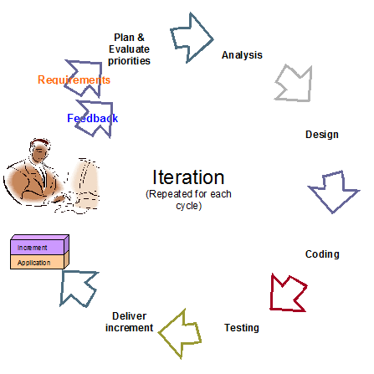

Figure 1: Agile Development Model

For more information: <http://www.indicthreads.com/1439/quick-introduction-to-agile-software-development/>

(Owner: IndicThreads.com. Online Software Developer Magazine and Conferences)

### Tools and Techniques

- Front-end technologies: HTML5, CSS3, JavaScript, jQuery, AJAX.

- Back-end:

* Website: ASP.NET MVC4 + Entity Framework 5.
* Scheduler: Quartz.
* Parse data from Excel file: linq to excel.

- Web Server: Microsoft IIS.

- Database Management System: MS SQL Server 2008 Enterprise R2.

## System Architectural Design

### Web Architecture

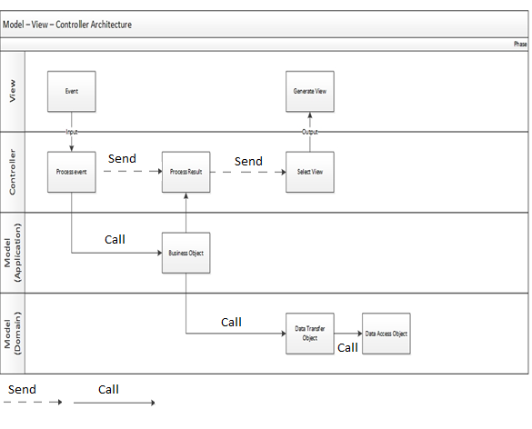

Figure 2: MVC Architecture

* **Model** is the part of the application that handles the logic for the application data. Often model objects retrieve data (and store data) from a database.
* **View** is the parts of the application that handles the display of the data. Most often the views are created from the model data.
* **Controller** is the part of the application that handles user interaction. Typically controllers read data from a view, control user input, and send input data to the model.

## Component Diagram

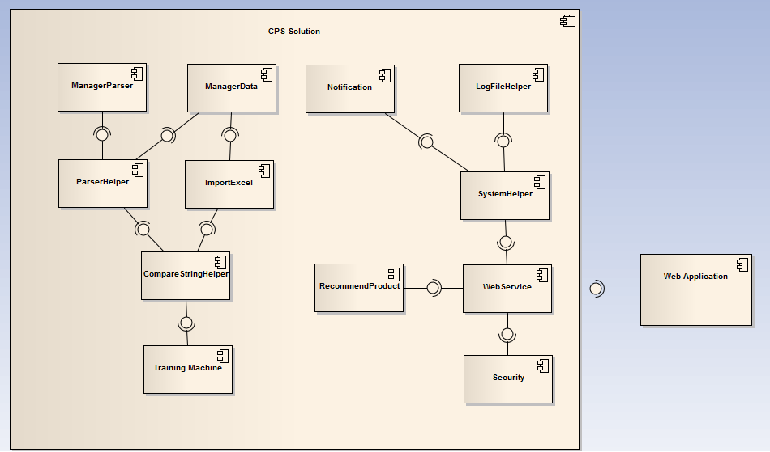

Figure 3: Component Diagram

## Conceptual Diagram

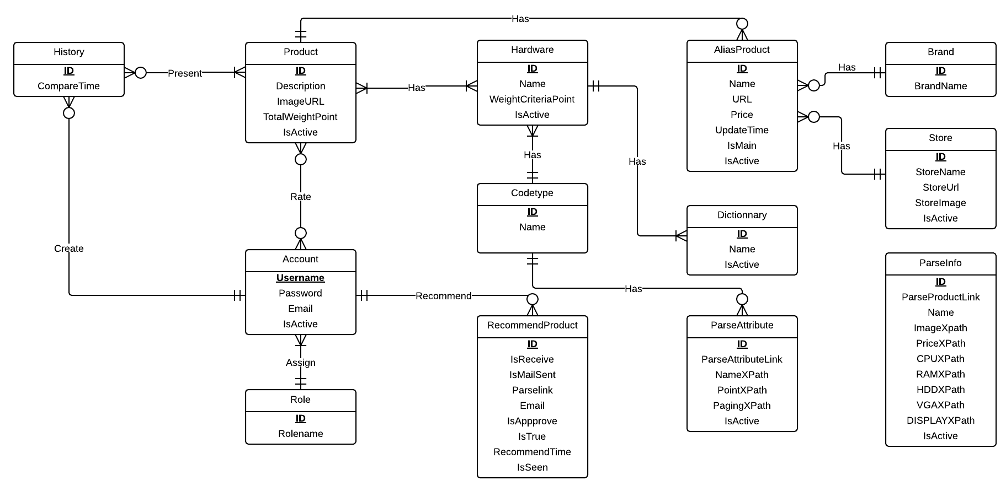

## Entity Relationship Diagram

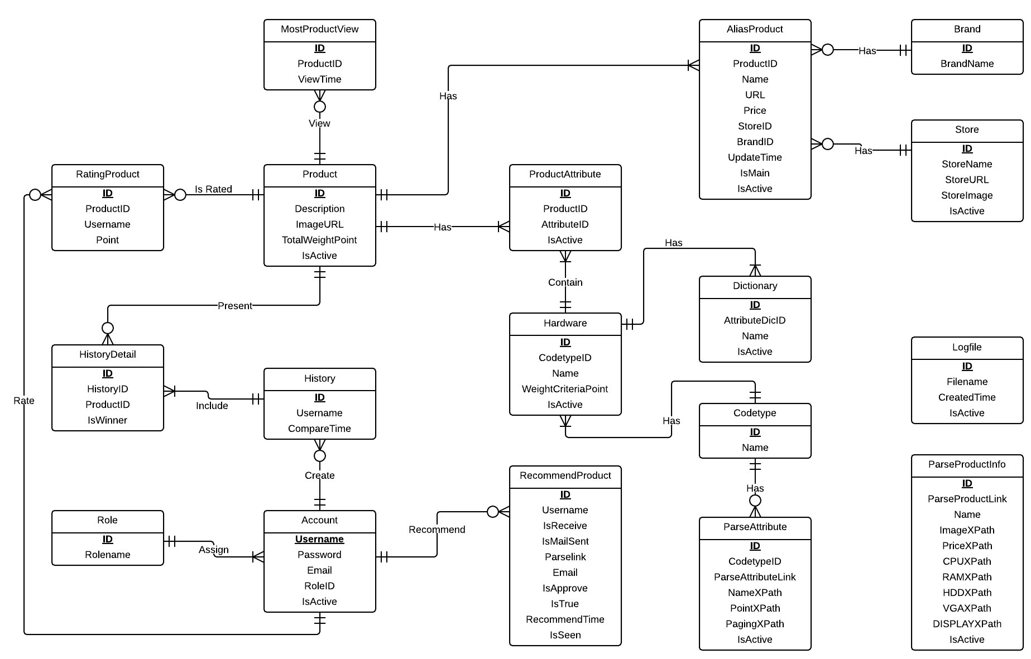

Figure 4: Entity Relationship Diagram

### Data Dictionary

|  |  |
| --- | --- |
| **Entity Data dictionary: describe content of all entities** | |
| **Entity Name** | **Description** |
| Codetype | Describe all codetype in the system. |
| ParseInfo | Describe all data needed to parse 1 specified product |
| Hardware | Describe all hardwares of a product. |
| Product | Describe all products in the system. |
| ProductAttribute | Describe relationship between Attribute and Product. |
| AliasProdcut | Describe all alias name of product in the system. |
| Dictionary | Describe all possible hardwares names in the system. |
| Account | Describe all accounts in the system. Account includes: admin, staff, member, guest… |
| RecommendProduct | Describe the product that user recommend for system. |
| History | Describe all compare histories of user in the system. |
| HistoryDetail | Describe details of any history in the system. |
| Role | Describe all roles in the system. One user has only one role. |
| LogFile | Describe all log files of the system. |
| ParserAttribute | Describe all Xpath to parser auto hardware |
| ParserInfo | Describe all Xpath to parser auto laptop. |
| RatingProduct | Describe relationship between Attribute and Product. |
| Brand | Describe all brand that product is included. |
| Store | Describe all store that product is included. |

Table 1: Entity Data Dictionary

|  |  |  |  |  |
| --- | --- | --- | --- | --- |
| **Entity name** | **Attributes** | **Description** | **Domain** | **Null** |
| Account | Username {PK} | The name chosen by user. | nvarchar(30) | No |
| Password | The password chosen by user. | nvarchar(30) | No |
| Email | The user email | nvarchar(100) | No |
| RoleID{FK} | Foreign key, role identifier. | int | No |
| IsActive | Account status. | bit | No |
| AliasProduct | ID {PK} | Unique identifier of a name, auto increment. | int | No |
| ProductID {FK} | Foreign key, product identifier. | int | No |
| Name | Name of product. | nvarchar(200) | No |
| URL | Url website get product. | nvarchar(200) | Yes |
| Price | Price of product. | float | Yes |
| StoreID | Foreign key, store identifier. | Int | Yes |
| BrandID | Foreign key, brand identifier. | bit | Yes |
| UpdateTime | Time update name | datetime | Yes |
| IsMain | Main name or alias name. | bit | Yes |
| IsActive | Status name | bit | No |
| Brand | Id {PK} | Unique identifier of a brand, auto increment. | int | No |
| Name | Brand name. | nvarchar(50) | Yes |
| Codetype | Id {PK} | Type id. | nvarchar(3) | No |
| Name | Type name. | nvarchar(50) | No |
| Dictionary | Id {PK} | Unique identifier of a hardware name, auto increment. | int | No |
| AttributeDicID {FK} | Foreign key, hardware identifier. | Int | No |
| Name | Hardware name. | nvarchar(200) | Yes |
| IsActive | Status of hardware name | bit | Yes |
| Hardware | ID {PK} | Unique identifier of hardware, auto increment. | int | No |
| CodetypeID {FK} | Foreign key, type. | nvarchar(3) | No |
| Name | Hardware main name. | nvarchar(200) | No |
| WeightCriteraPoint | Score of hardware | float | No |
| IsActive | Status of hardware | bit | Yes |
| History | Id {PK} | Unique identifier a history, auto increment. | int | No |
| Username {FK} | User compare | nvarchar(30) | No |
| CompareTime | Compare time. | Datetime | No |
| HistoryDetail | ID {PK} | Unique identifier of history detail, auto increment. | Int | No |
| HistoryID {FK} | Foreign key, history identifier. | int | No |
| ProductID {FK} | Foreign key, product identifier. | int | No |
| isWinner | The winer product | bit | Yes |
| LogFile | ID {PK} | Unique identifier of logfile, auto increment. | Int | No |
| Filename | Name of logfile. | nvarchar(100) | No |
| CreatedTime | Time generate logfile. | datetime | Yes |
| IsActive | Status of logfile | bit | No |
| MostViewProduct | Id {PK } | Unique identifier of most view product, auto increment. | int | No |
| ProductID {FK} | Foreign key, product of this. | Int | No |
| ViewTime | The time view product. | datetime | No |
| ParseAttribute | Id {PK} | Unique identifier of parser hardware, auto increment. | int | No |
| CodetypeID {FK} | Foreign key, type hardware. | nvarchar(3) | No |
| ParseAttributelink | Parser link. | nvarchar(200) | No |
| NameXPath | Xpath of hardware name. | nvarchar(200) | No |
| PointXPath | Xpath of hardware score | nvarchar(200) | No |
| PagingXPath | Xpath of paging | nvarchar(200) | Yes |
| IsActive |  | bit | No |
| ParseInfo | Id {PK} | Unique identifier of a parser, auto increment. | int | No |
| Parselink | Url website parser product | nvarchar(200) | No |
| Name | Xpath product name. | nvarchar(200) | No |
| PriceXPath | Xpath product price. | nvarchar(200) | Yes |
| ImageXpath | Xpath product image. | nvarchar(200) | Yes |
| CPUXPath | Xpath product cpu. | nvarchar(200) | No |
| RAMXPath | Xpath product Ram. | nvarchar(200) | No |
| VGAXPath | Xpath product vga. | nvarchar(200) | No |
| HDDXPath | Xpath product hdd. | nvarchar(200) | No |
| DisplayXPath | Xpath product display. | nvarchar(200) | No |
| IsActive | Status of parser. | bit | No |
| Product | Id {PK} | Unique identifier of product, auto increment. | int | No |
| Description | Descripton of product. | nchar(2000) | Yes |
| ImageURL | Product url image. | nvarchar(2000) | Yes |
| TotalWeightPoint | Score of product | Float | No |
| IsActive | Status of product | bit | Yes |
| ProductAttribute | Id {PK} | Unique identifier of productattribute  , auto increment. | int | No |
| ProductId {FK} | Foreign key, product identifier. | int | No |
| AttributeID {FK} | Foreign key, hardware identifier. | int | No |
| IsActive | Status of product attributes. | bit | Yes |
| RatingProduct | Id {PK} | Unique identifier of rating, auto increment. | int | No |
| ProductId {FK} | Foreign key, product identifier. | int | No |
| Username {FK} | Foreign key, account. | nvarchar(30) | No |
| Point | Rating point. | Float | No |
| RecommendProduct | Id {PK} | Unique identifier of recommend, auto increment. | int | No |
| Username {FK} | Foreign key, account. | nvarchar(30) | No |
| IsReceive | Status send notify. | bit | No |
| IsMailSent | Status sends email. | bit | No |
| Parselink | Link recommends. | nvarchar(200) | Yes |
| Email | Email to send. | nvarchar(200) | No |
| IsApprove | Status approves recommend. | bit | Yes |
| IsTrue | Status of recommend. | Bit | Yes |
| RecommendTime | Time of recommend. | Datetime | Yes |
| IsSeen | Status seen notify. | bit | No |
| Role | Id {PK} | Unique identifier of role, auto increment. | int | No |
| Rolename | Role name. | nvarchar(50) | No |
| Store | Id {PK} | Unique identifier of store, auto increment. | int | No |
| StoreName | Store name. | nvarchar(200) | Yes |
| StoreUrl | Store url website. | nvarchar(200) | Yes |
| LogoImage | Store url image. | nvarchar(200) | Yes |
| IsActive | Status of store. | bit | Yes |

Table 2: Attribute Data Dictionary

## Class Diagram

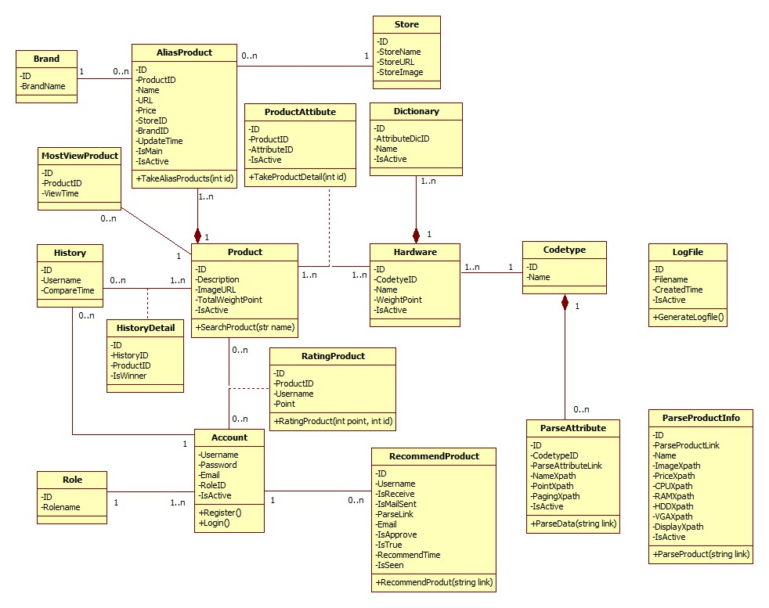

Figure 5: Class Diagram

### Class Diagram Explanation

#### Codetype

Attribute

|  |  |  |  |
| --- | --- | --- | --- |
| **Attribute** | **Type** | **Visibility** | **Description** |
| Id | Integer | Public | Unique identifier of each code type |
| Name | String | Public | Name of code type |
| IsActive | Boolean | Public | Status of code type |

#### ParseAttribute

Attribute

|  |  |  |  |
| --- | --- | --- | --- |
| **Attribute** | **Type** | **Visibility** | **Description** |
| Id | Integer | Public | Unique identifier of each item |
| CodetypeID | String | Public | Id of codetype |
| ParseAttributeLink | String | Public | Link used to parse |
| NameXpath | String | Public | Xpath to get the name of attribute |
| PointXpath | String | Public | Xpath to get the point of attribute |
| PagingXpath | String | Public | Xpath to get the paging |
| IsActive | Boolean | Public | Status of attribute |

Method

|  |  |  |  |
| --- | --- | --- | --- |
| **Method** | **Return type** | **Visibility** | **Description** |
| ParseData | Void | Public | Run parser to get data |

#### Hardware

Attribute

|  |  |  |  |
| --- | --- | --- | --- |
| **Attribute** | **Type** | **Visibility** | **Description** |
| Id | Integer | Public | Unique identifier of each item |
| CodetypeId | Integer | Public | Id of codetype |
| Name | String | Public | Name of attribute |
| WeightCriteriaPoint | Integer | Public | Point of each hardware |
| IsActive | Boolean | Public | Status of Hardware |

#### Dictionary

Attribute

|  |  |  |  |
| --- | --- | --- | --- |
| **Attribute** | **Type** | **Visibility** | **Description** |
| Id | Integer | Public | Unique identifier of each product |
| AttributeID | Integer | Public | Id of attribute |
| Name | String | Public | Name of attribute |
| IsActive | Boolean | Public | Status of Dictionnary |

#### Product

Attribute

|  |  |  |  |
| --- | --- | --- | --- |
| **Attribute** | **Type** | **Visibility** | **Description** |
| Id | Integer | Public | Unique identifier of each item |
| Description | String | Public | Description of this product |
| ImageURL | String | Public | ImageURL of this product |
| TotalWeightPoint | Double | Public | Point of this product |
| IsActive | Boolean | Public | Status of product |

Method

|  |  |  |  |
| --- | --- | --- | --- |
| **Method** | **Return type** | **Visibility** | **Description** |
| Search Product | Product | Public | Search product in system |

#### MostViewProduct

Attribute

|  |  |  |  |
| --- | --- | --- | --- |
| **Attribute** | **Type** | **Visibility** | **Description** |
| Id | Integer | Public | Unique identifier of each item |
| ProductID | String | Public | ID of each Product |
| ViewTime | Int | Public | View time of each product. |

Method

|  |  |  |  |
| --- | --- | --- | --- |
| **Method** | **Return type** | **Visibility** | **Description** |
| LoadMostProduct | Product | Public | Load most view product |

#### Product Attribute

Attribute

|  |  |  |  |
| --- | --- | --- | --- |
| **Attribute** | **Type** | **Visibility** | **Description** |
| Id | Integer | Public | Unique identifier of each item |
| ProductID | Int | Public | Id of product |
| AttributeID | Int | Public | Id of attribute |
| IsActive | Boolean | Public | Status of each attribute |

#### AliasProduct

Attribute

|  |  |  |  |
| --- | --- | --- | --- |
| **Attribute** | **Type** | **Visibility** | **Description** |
| ID | Int | Public | Unique identifier of each item |
| ProductID | Int | Public | Id of product |
| Name | String | Public | Product name |
| URL | String | Public | URL of product |
| Price | Double | Public | Price of each produt |
| StoreID | Int | Public | Id of store |
| BrandID | Int | Public | Id of brand |
| UpdateTime | Datetime | Public | Time update that product |
| IsMain | Boolean | Public | Describe which main product is. |
| IsActive | Boolean | Public | Status of this productalias |

#### History

Attribute

|  |  |  |  |
| --- | --- | --- | --- |
| **Attribute** | **Type** | **Visibility** | **Description** |
| Id | Integer | Public | Unique identifier of each history |
| Username | String | Public | Owner of this history |
| CompareTime | DateTime | Public | The time when owner compare product |

#### History Detail

Attribute

|  |  |  |  |
| --- | --- | --- | --- |
| **Attribute** | **Type** | **Visibility** | **Description** |
| Id | Integer | Public | Unique identifier of each item |
| HistoryId | Integer | Public | Id of history |
| ProductId | Integer | Public | Id of product |
| IsWinner | Boolean | Public | Winner Product |

#### Role

Attribute

|  |  |  |  |
| --- | --- | --- | --- |
| **Attribute** | **Type** | **Visibility** | **Description** |
| Id | Integer | Public | Unique identifier of each role |
| Name | String | Public | Role name |

#### Log File

Attribute

|  |  |  |  |
| --- | --- | --- | --- |
| **Attribute** | **Type** | **Visibility** | **Description** |
| Id | Integer | Public | Unique identifier of each file |
| FileName | String | Public | File name |
| CreatedTime | DateTime | Public | The time when this file is created |
| IsActive | Boolean | Public | Status of this file |

Method

|  |  |  |  |
| --- | --- | --- | --- |
| **Method** | **Return type** | **Visibility** | **Description** |
| GenerateLogFile | Boolean | Public | Generate log file for each time system runs the parser |

#### Rating Product

Attribute

|  |  |  |  |
| --- | --- | --- | --- |
| **Attribute** | **Type** | **Visibility** | **Description** |
| Id | Integer | Public | Unique id of each item |
| Username | String | Public | The name of the user |
| ProductId | Integer | Public | The identifier of that product |
| Point | Integer | Public | Rating point of each product |

|  |  |  |  |
| --- | --- | --- | --- |
| **Method** | **Return type** | **Visibility** | **Description** |
| RatingProduct | Void | Public | rating price for the system |

#### Recommend Product

|  |  |  |  |
| --- | --- | --- | --- |
| **Attribute** | **Type** | **Visibility** | **Description** |
| Id | Integer | Public | Unique id of each item |
| Username | String | Public | The name of the user |
| IsReceive | Boolean | Public | Receive mail when update product/ |
| IsMailSent | Boolean | Public | Send email or not yet. |
| Parselink | String | Public | Link that user recommend |
| Email | String | Public | Email of user |
| IsApprove | Boolean | Public | Status of recommend |
| IsTrue | Boolean | Public | Status of auto parse recommend. |
| RecommendTime | Datetime | Public | Time that user recommend |
| IsSeen | Boolean | Public | Status of notification for user |

|  |  |  |  |
| --- | --- | --- | --- |
| **Method** | **Return type** | **Visibility** | **Description** |
| RecommendProduct | Void | Public | Recommend product for system |

#### Parse Product Info

|  |  |  |  |
| --- | --- | --- | --- |
| **Attribute** | **Type** | **Visibility** | **Description** |
| Id | Integer | Public | Unique id of each item |
| ParseLink | String | Public | Link to get parser |
| Name | String | Public | Xpath to get the Name |
| PriceXpath | String | Public | Xpath to get the Price |
| ImageXpath | String | Public | Image to get the Name |
| CPUXpath | String | Public | Xpath to get the CPU |
| HDDXpath | String | Public | Xpath to get the HDD |
| VGAXpath | String | Public | Xpath to get the VGA |
| RAMXpath | String | Public | Xpath to get the RAM |
| DisplayXpath | String | Public | Xpath to get the Display |
| IsActive | String | Public | Status of parser |

#### Account

Attribute

|  |  |  |  |
| --- | --- | --- | --- |
| **Attribute** | **Type** | **Visibility** | **Description** |
| Username | String | Public | Unique username of each user |
| Password | String | Public | Password of user |
| Email | String | Public | Email of User |
| RoleId | Int | Public | Account roles ID |
| IsActive | String | Public | Status of account |

Method

|  |  |  |  |
| --- | --- | --- | --- |
| **Method** | **Return type** | **Visibility** | **Description** |
| Register | Boolean | Public | Register a new account in system |
| Login | Boolean | Public | Check if is existed account in system |

#### Store

Attribute

|  |  |  |  |
| --- | --- | --- | --- |
| **Attribute** | **Type** | **Visibility** | **Description** |
| ID | Int | Public | Unique of each store |
| StoreName | String | Public | Name of store |
| StoreUrl | String | Public | Url of each store |
| LogoImage | String | Public | Image URL of each store |
| IsActive | String | Public | Status of store |

#### Brand

Attribute

|  |  |  |  |
| --- | --- | --- | --- |
| **Attribute** | **Type** | **Visibility** | **Description** |
| ID | Int | Public | Unique of each Brand |
| BrandName | String | Public | Name of each Brand |

## Database Relationship Diagram

### Diagram

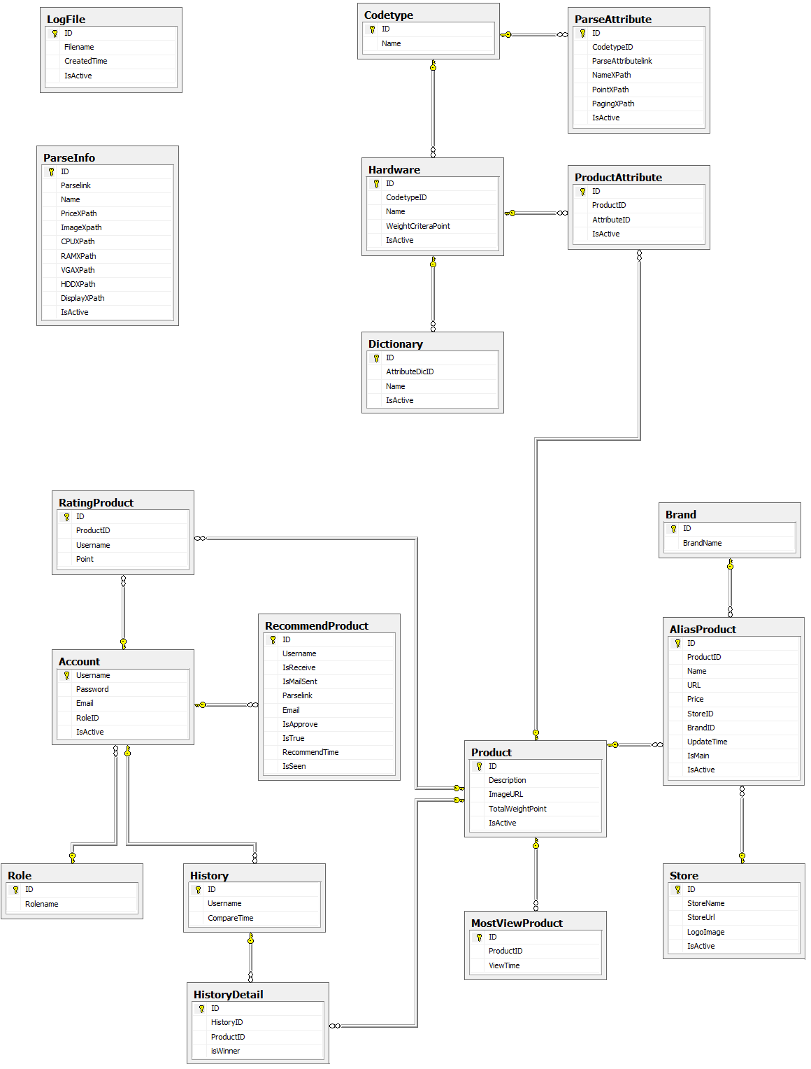

Figure 6: Database Relationship Diagram

### Data Dictionary

|  |  |
| --- | --- |
| **Entity Data dictionary: describe content of all entities** | |
| Entity Name | Description |
| Account | Describe all accounts in the system. Account includes: admin, staff, member, guest… |
| AliasProduct | Describe product the main name and alias name. |
| Brand | Describe brand of product in the system. |
| Codetype | Describe type of hardware. |
| Dictionary | Describe hardware the main name and alias name. |
| Hardware | Describe all accounts in the system. |
| History | Describe time compare of user. |
| HistoryDetail | Describe detail compare of user. |
| LogFile | Describe all log files of the system. Log file is generated after parsers finish running. |
| MostViewProduct | Describe product view time. |
| ParseAttribute | Describe all Xpath to auto parser hardware |
| ParseInfo | Describe all Xpath to auto parser laptop. |
| Product | Describe all products. |
| ProductAttribute | Describe hardware of each product. |
| RatingProduct | Describe rating point of product and user rating. |
| RecommendProduct | Describe all info product guests and user recommend for system. |
| Role | Describe all roles in the system. |
| Store | Describe all store of product in the system. |

Table 3: Data Dictionary

|  |  |  |  |  |
| --- | --- | --- | --- | --- |
| **Entity name** | **Attributes** | **Description** | **Domain** | **Null** |
| Account | Username {PK} | The name chosen by user. | nvarchar(30) | No |
| Password | The password chosen by user. | nvarchar(30) | No |
| Email | The user email | nvarchar(100) | No |
| RoleID{FK} | Foreign key, role identifier. | int | No |
| IsActive | Account status. | bit | No |
| AliasProduct | ID {PK} | Unique identifier of a name, auto increment. | int | No |
| ProductID {FK} | Foreign key, product identifier. | int | No |
| Name | Name of product. | nvarchar(200) | No |
| URL | Url website get product. | nvarchar(200) | Yes |
| Price | Price of product. | float | Yes |
| StoreID | Foreign key, store identifier. | Int | Yes |
| BrandID | Foreign key, brand identifier. | bit | Yes |
| UpdateTime | Time update name | datetime | Yes |
| IsMain | Main name or alias name. | bit | Yes |
| IsActive | Status name | bit | No |
| Brand | Id {PK} | Unique identifier of a brand, auto increment. | int | No |
| Name | Brand name. | nvarchar(50) | Yes |
| Codetype | Id {PK} | Type id. | nvarchar(3) | No |
| Name | Type name. | nvarchar(50) | No |
| Dictionary | Id {PK} | Unique identifier of a hardware name, auto increment. | int | No |
| AttributeDicID {FK} | Foreign key, hardware identifier. | Int | No |
| Name | Hardware name. | nvarchar(200) | Yes |
| IsActive | Status of hardware name | bit | Yes |
| Hardware | ID {PK} | Unique identifier of hardware, auto increment. | int | No |
| CodetypeID {FK} | Foreign key, type. | nvarchar(3) | No |
| Name | Hardware main name. | nvarchar(200) | No |
| WeightCriteraPoint | Score of hardware | float | No |
| IsActive | Status of hardware | bit | Yes |
| History | Id {PK} | Unique identifier a history, auto increment. | int | No |
| Username {FK} | User compare | nvarchar(30) | No |
| CompareTime | Compare time. | Datetime | No |
| HistoryDetail | ID {PK} | Unique identifier of history detail, auto increment. | Int | No |
| HistoryID {FK} | Foreign key, history identifier. | int | No |
| ProductID {FK} | Foreign key, product identifier. | int | No |
| isWinner | The winer product | bit | Yes |
| LogFile | ID {PK} | Unique identifier of logfile, auto increment. | Int | No |
| Filename | Name of logfile. | nvarchar(100) | No |
| CreatedTime | Time generate logfile. | datetime | Yes |
| IsActive | Status of logfile | bit | No |
| MostViewProduct | Id {PK } | Unique identifier of most view product, auto increment. | int | No |
| ProductID {FK} | Foreign key, product of this. | Int | No |
| ViewTime | The time view product. | datetime | No |
| ParseAttribute | Id {PK} | Unique identifier of parser hardware, auto increment. | int | No |
| CodetypeID {FK} | Foreign key, type hardware. | nvarchar(3) | No |
| ParseAttributelink | Parser link. | nvarchar(200) | No |
| NameXPath | Xpath of hardware name. | nvarchar(200) | No |
| PointXPath | Xpath of hardware score | nvarchar(200) | No |
| PagingXPath | Xpath of paging | nvarchar(200) | Yes |
| IsActive |  | bit | No |
| ParseInfo | Id {PK} | Unique identifier of a parser, auto increment. | int | No |
| Parselink | Url website parser product | nvarchar(200) | No |
| Name | Xpath product name. | nvarchar(200) | No |
| PriceXPath | Xpath product price. | nvarchar(200) | Yes |
| ImageXpath | Xpath product image. | nvarchar(200) | Yes |
| CPUXPath | Xpath product cpu. | nvarchar(200) | No |
| RAMXPath | Xpath product Ram. | nvarchar(200) | No |
| VGAXPath | Xpath product vga. | nvarchar(200) | No |
| HDDXPath | Xpath product hdd. | nvarchar(200) | No |
| DisplayXPath | Xpath product display. | nvarchar(200) | No |
| IsActive | Status of parser. | bit | No |
| Product | Id {PK} | Unique identifier of product, auto increment. | int | No |
| Description | Descripton of product. | nchar(2000) | Yes |
| ImageURL | Product url image. | nvarchar(2000) | Yes |
| TotalWeightPoint | Score of product | Float | No |
| IsActive | Status of product | bit | Yes |
| ProductAttribute | Id {PK} | Unique identifier of productattribute  , auto increment. | int | No |
| ProductId {FK} | Foreign key, product identifier. | int | No |
| AttributeID {FK} | Foreign key, hardware identifier. | int | No |
| IsActive | Status of product attributes. | bit | Yes |
| RatingProduct | Id {PK} | Unique identifier of rating, auto increment. | int | No |
| ProductId {FK} | Foreign key, product identifier. | int | No |
| Username {FK} | Foreign key, account. | nvarchar(30) | No |
| Point | Rating point. | Float | No |
| RecommendProduct | Id {PK} | Unique identifier of recommend, auto increment. | int | No |
| Username {FK} | Foreign key, account. | nvarchar(30) | No |
| IsReceive | Status send notify. | bit | No |
| IsMailSent | Status sends email. | bit | No |
| Parselink | Link recommends. | nvarchar(200) | Yes |
| Email | Email to send. | nvarchar(200) | No |
| IsApprove | Status approves recommend. | bit | Yes |
| IsTrue | Status of recommend. | Bit | Yes |
| RecommendTime | Time of recommend. | Datetime | Yes |
| IsSeen | Status seen notify. | bit | No |
| Role | Id {PK} | Unique identifier of role, auto increment. | int | No |
| Rolename | Role name. | nvarchar(50) | No |
| Store | Id {PK} | Unique identifier of store, auto increment. | int | No |
| StoreName | Store name. | nvarchar(200) | Yes |
| StoreUrl | Store url website. | nvarchar(200) | Yes |
| LogoImage | Store url image. | nvarchar(200) | Yes |
| IsActive | Status of store. | bit | Yes |

### Table 4: Attribute Data Dictionary

## Sequence Diagram

### Force Parse Data

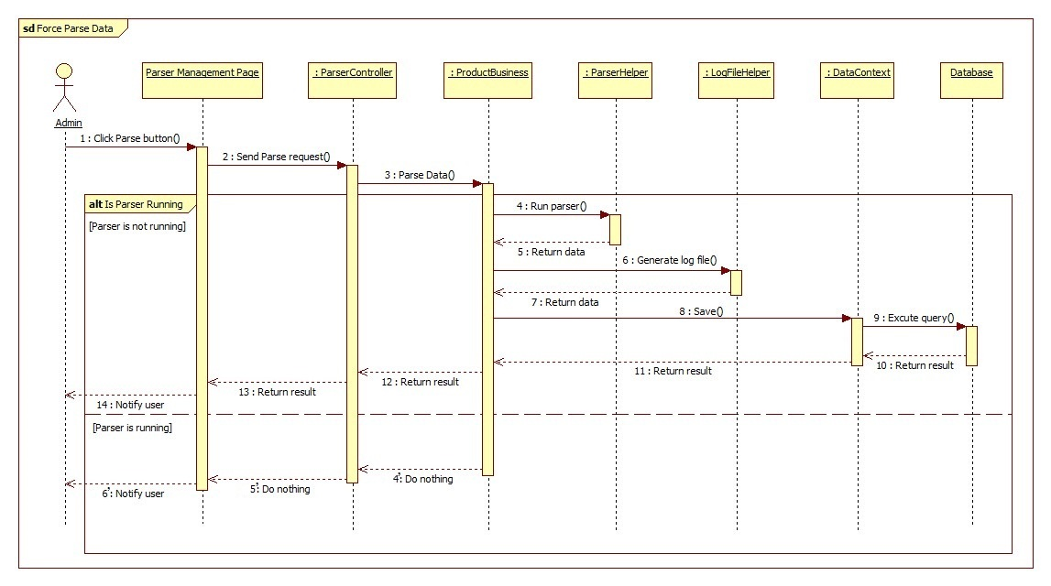

Figure 7: Force Parse Data Sequence Diagram

### Import Product

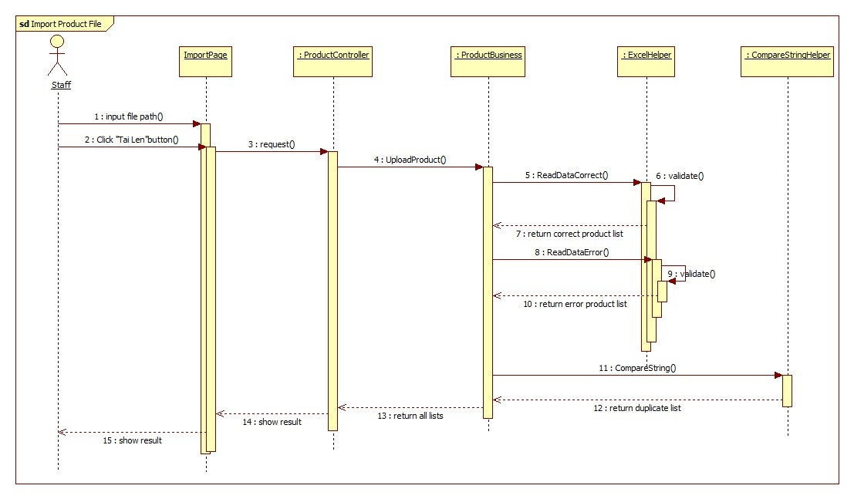

Figure 8: Import Product Sequence Diagram

### Process Error Products

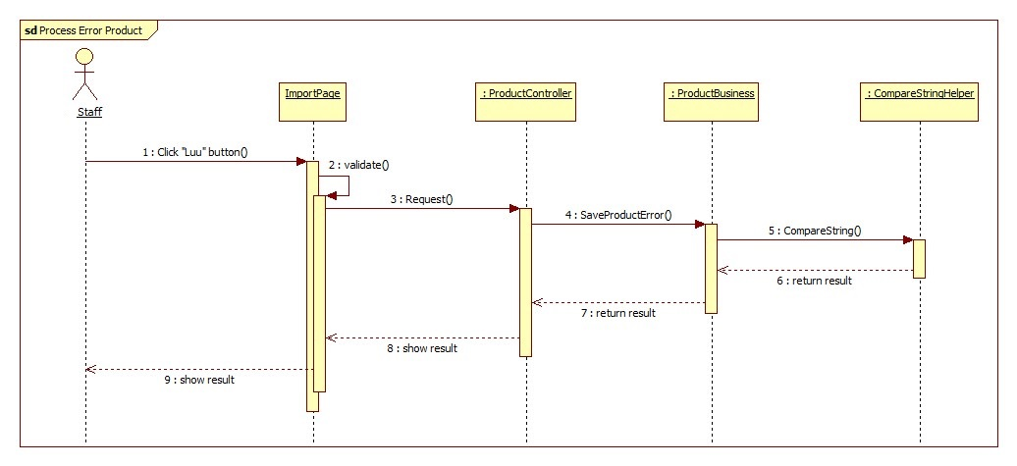

Figure 9: Process Error Products Sequence Diagram

### Process Duplicated Products

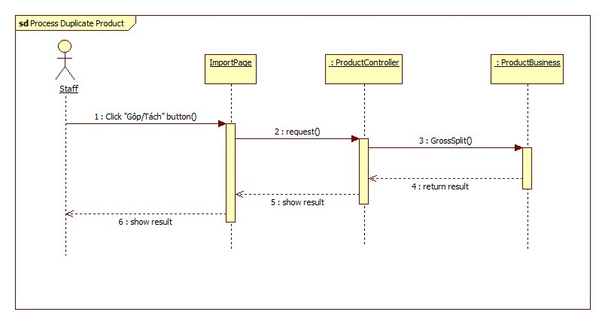

Figure 10: Process Duplicated Products Sequence Diagram

### Save Correct Products

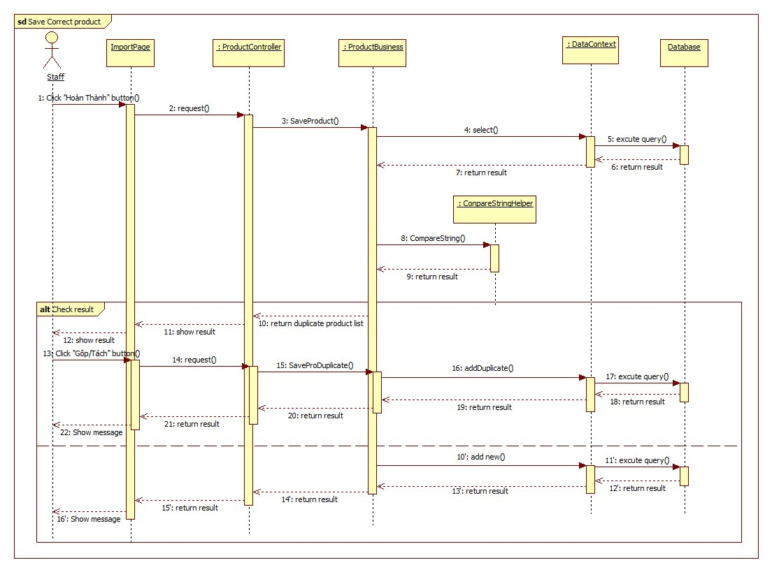

Figure 11: Save Correct Products Sequence Diagram

### Log File

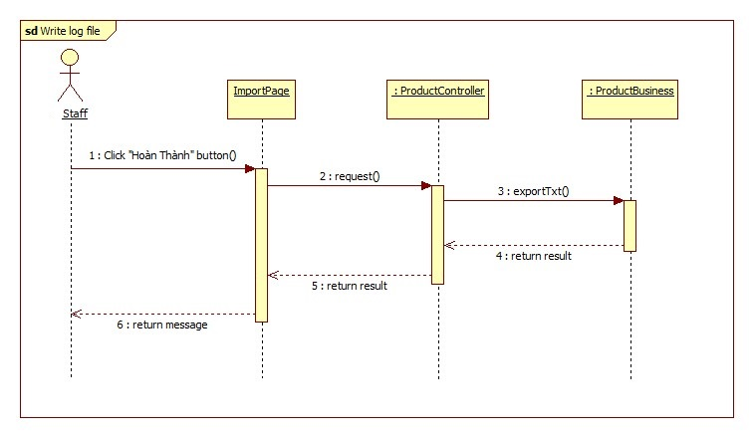

Figure 12: Log File Sequence Diagram

### Recommend

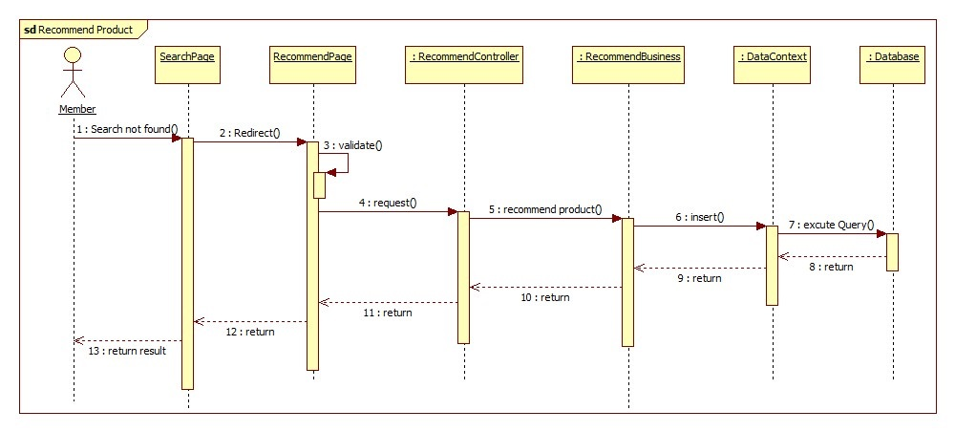

#### Figure 13: Recommend Sequence Diagram

### View History

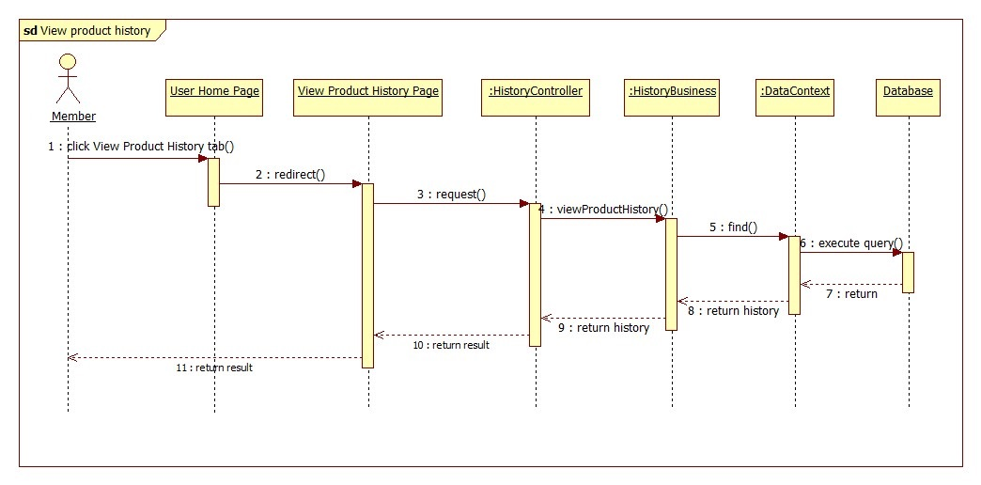

Figure 14: View History Sequence Diagram

### Search Product

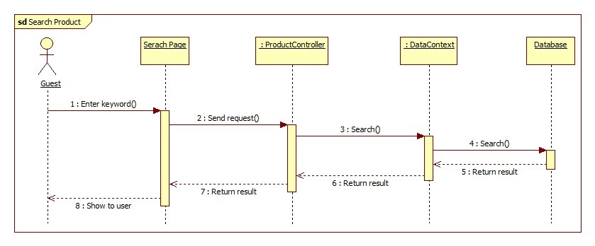

Figure 15: Search Product Sequence Diagram

### Configure System

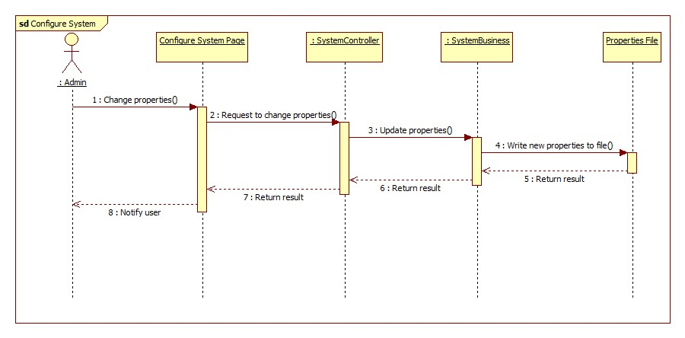

Figure 16: Configure System Sequence Diagram

### Confirm New Product

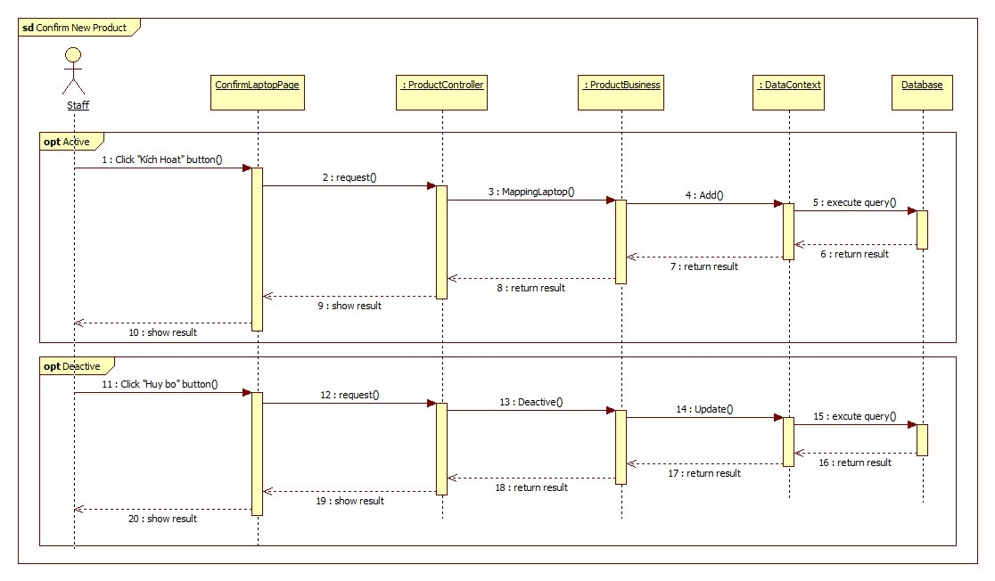

Figure 17: Confim New Product

### Training Machine

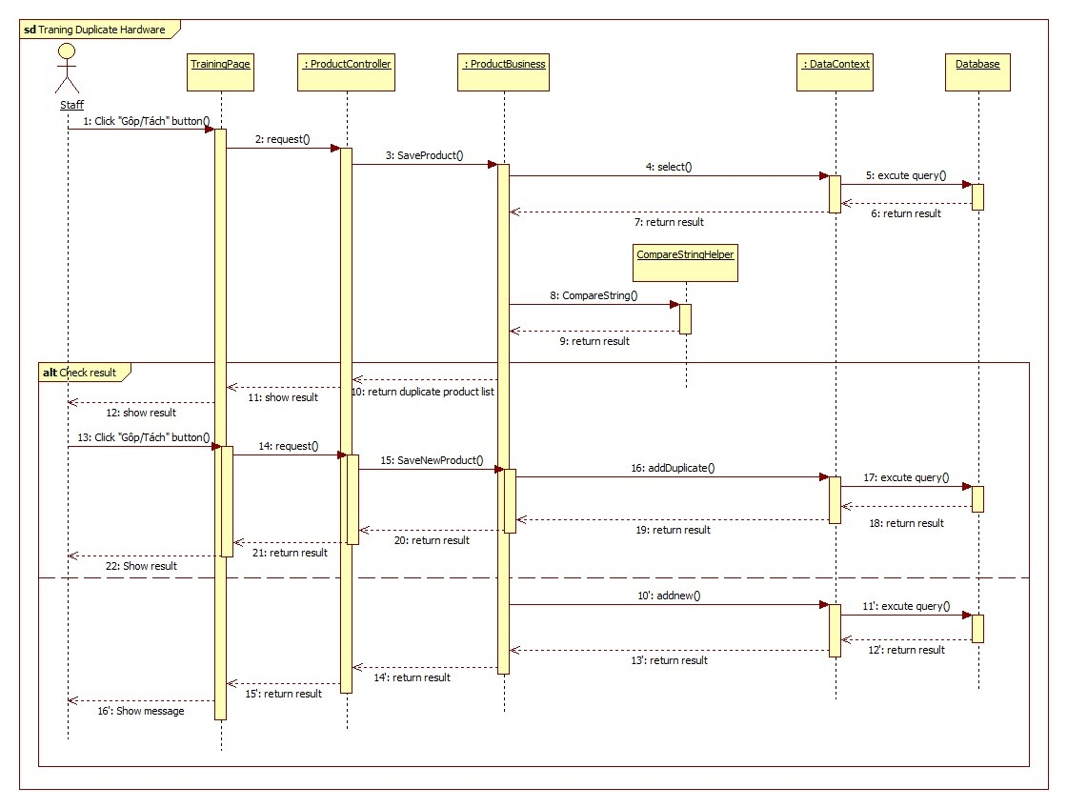

Figure 18: Training Machine

## Algorithms

### Calculating Product’s Score

#### Reduce hardware’s score on the scale from 1 to 100

* Define:
  + x : The highest hardware’s score in the database.
  + y : The hardware’s score in the database.
  + z : The hardware’s scor on the scale from 1 to 100 after reduced.
* We have a reduce formular:
$$z=\frac{100}{x}×y$$

* Example: Reduce the CPU’s score on the scale from 1 to 100.
  + Given the highest CPU’s score in the database: ***x*** = 13200.
  + Given the CPU’s score which we will reduce: ***y*** = 8000.
  + And ***z*** is the CPU’s score on the scale form 1 to 100.
  + Apply the reduce formular:

$$z=\frac{100}{13200}×8000$$

$z= 60.61$ (on the scale from 1 to 100).

#### Calculate product’s score

* After calculated all the score of CPU, VGA, RAM, HDD and Display on the scale from 1 to 100, we can calculate the product score.
* Given:
  + c : CPU’s score.
  + v : VGA’s score.
  + r : RAM’s score.
  + h : HDD’s score.
  + P : Product’s score.
* Define the formular to calculate product’s score:

$$P=\frac{\left(c+v\right)×60\%+\left(r+h+d\right)×40\%}{5}$$

### String Comparison

##### **Define** Problem

* Given two strings. Calculate their matching percent.

##### Requirement

* Robustness to changes of word order: two strings which contain the same words, but in a different order, should be recognised as being similar.
* Language independence: the algorithm should work not only in English, but in many different languages.

##### Solution

* If a string contains many words, break it into a list of words.
* For each word, we find out how many adjacent character pairs are contained in it.
* Create a function *pairs(s)* which returns a list of adjacent character pairs of string *s*.
* Then, we use below formula to calculate matching percent.

$similarity\left(s1,s2\right)=\frac{2×\left|pairs(s1)∩pairs(s2)\right|}{\left|pairs\left(s1\right)\right|+\left|pairs(s2)\right|}$

##### Example

Calculate the matching percent of 2 strings: France and French.

* Upper case 2 strings:
  + France $→$ FRANCE.
  + French $→$ FRENCH.
* Break string into list of adjacent character pairs:
  + FRANCE $→\left\{FR,RA,AN,NC,CE\right\}$
  + FRENCH $→\left\{FR,RE,EN,NC,CH\right\}$
* Calculate its matching percent.

$$similarity\left(FRANCE,FRENCH\right)$$

$$=\frac{2×\left|\left\{FR,NC\right\}\right|}{\left|\left\{FR,RA,AN,NC,CE\right\}\right|+\left|\left\{FR,RE,EN,NC,CH\right\}\right|}=\frac{2×2}{5+5}=\frac{4}{10}=0.4$$

## Demo

### Scenario

### Scenario

* Sang is a developer and he want to buy a new laptop.
* He finds out 2 laptops, they are HP 15 – D102TX and HP Pavilion 14 – R006TU.
* These laptops are all suitable for his job, but he doesn’t know which laptop is the better.

### Script demo case 1: Sang is a guest of CPS website, he doesn’t log in to CPS:

* Sang go to CPS website, then searchs 2 laptops: HP 15 – D102TX and HP Pavilion 14 – R006TU
* After he founded each of them, he add it to compare cart.
* When 2 laptops are added, he click compare button to compare 2 laptops.
* Compare page show to Sang 2 product with its score. The better of 2 laptops will be highlighted.

### Script demo case 2: Sang is a member of CPS website, he logged in to CPS:

* Sang go to CPS website, then searchs 2 laptops: HP 15 – D102TX and HP Pavilion 14 – R006TU
* After he founded each of them, he add it to compare cart.
* When 2 laptops are added, he click compare button to compare 2 laptops.
* Compare page show to Sang 2 product with its score and price for 1 point. The better of 2 laptops will be highlighted.
* Then, he wants to compare which laptop is better in specify hardwares, he click “So Sánh Chi Tiết” to view compare detail page.
* At compare detail page, he drag and drop the hardware which he wants to compare.

### Script demo case 3: Sang doesn’t found the laptop he wants to search, he recommends that laptop for CPS website

* Sang search a laptop but result was “Not found”, he click to a link in the message to send a recommend to CPS.
* He copy the link which contain information of laptop that he want to recommend and paste to the textbox.
* System checks the link then auto fill email in the email textbox to receive information when product is added to database.
* He click “Gửi đề xuất” button to complete recommend.

## Advantages and disadvantages

### Advantages

* Provide full of details suggest about specified product that you want to know and see what product is better than the other ones. It saves your time, because it takes a few minutes instead of several hours to compare the details (all text) and still don’t know which one is under your budget and better. You will never miss out a special, coupon or rebate. Finally, you can get real life reviews, recommend and rating from the other users.
* The system collect product form abundant sources.

### Disadvantages

* Staffs spend time for tranining.
* Not support mobie version.
* Not provide Payment Method.
* Staff must have knowledge about hardware